Mustang V-Labs - Instructions for Chromebook to Windows
Official URL: https://services.smsu.edu/TDClient/180/Portal/KB/Article/2502/Mustang-V-Labs-Instructions-for-Chromebook-to-Windows
Category: Knowledge Base > Information Technology Services > Software and Applications > Mustang V-Labs - Instructions for Chromebook to Windows
Tags: network, access, windows, vlabs, mustangvlabs, remote
_____________________________________________________
ATTENTION:
- Your username is: campus\YourStarID (i.e., smsu.edu\ab1234cd)
- Your password is: your StarID password
- Remember to log off and save your files to OneDrive or email them to yourself. Files saved directly on these computers will be deleted.
- New users: Download the Microsoft Remote Desktop app from the Play Store. Search for "Microsoft Remote Desktop" and download the app.
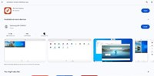
Figure 1: Uploaded Image (Thumbnail)
- Once you have downloaded and launched the application, Click the "+" button in the top right corner and select "Add PC".
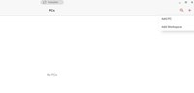
Figure 2: Uploaded Image (Thumbnail)
- After clicking "Add PC," fill in the required information based on the instructions below:
PC name: fk25st3.smsu.edu
User account: smsu.edu\StarID (i.e., smsu.edu\ab1234cd)
Admin mode: Enabled
Gateway: smsu.edu:8443
Ensure don’t use for local address' is off
Click the "Save" button when you have filled in all the required information.
- PC name: fk25st3.smsu.edu
- User account: smsu.edu\StarID (i.e., smsu.edu\ab1234cd)
- Admin mode: Enabled
- Gateway: smsu.edu:8443
- Ensure don’t use for local address' is off
- Click the "Save" button when you have filled in all the required information.
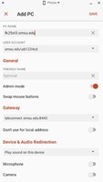
Figure 3: Uploaded Image (Thumbnail)
- Once you've added the PC, click or type the link below in a new browser to connect to any of the available computers listed. Connect to any of the listed computers by clicking the "Connect" button to the right of desired computer: https://remoteaccess.labstats.com/Southwest-Minnesota-State-University
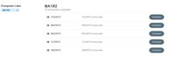
Figure 4: Uploaded Image (Thumbnail)
- Clicking the "Connect" button for your desired computer prompts you to download and open the connection file, followed by the listed steps.
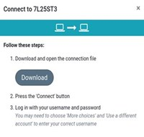
Figure 5: Uploaded Image (Thumbnail)
- When you download the file, it opens as a text file. To use it for remote desktop, you need to go to your Downloads folder and open it with the remote desktop application.
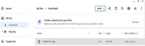
Figure 6: Uploaded Image (Thumbnail)
- Remember to switch to tablet mode for a larger view. By default, it opens in phone mode.
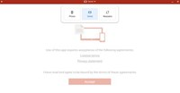
Figure 7: Uploaded Image (Thumbnail)
- Once you open the text file using Remote Desktop (RDP), you'll need to enter your username and password to gain access.
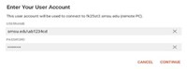
Figure 8: Uploaded Image (Thumbnail)
- Click Connect to verify certificate.
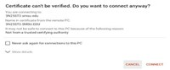
Figure 9: Uploaded Image (Thumbnail)
- Always remember to log off the computer when you are finished using it.
NOTE: For returning users, start from step 2.
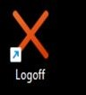
Figure 10: Uploaded Image (Thumbnail)
Accessibility Review & Update Log:
- [ ] Content accuracy verified
- [ ] Color contrast checked
- [x] Image alt-text verified (screenshots auto-captioned)
- [x] Document structure and headings formatted (perfect bold, list bulletpoints and sequences preserved)

